**How to Rotate Models Using Maya**

* Export your surface file from Avizo as a little endian STL file (make sure you have an un-altered copy)
* Open up Maya an either drag & drop your file into a blank scene or go up to File/Import/Select File

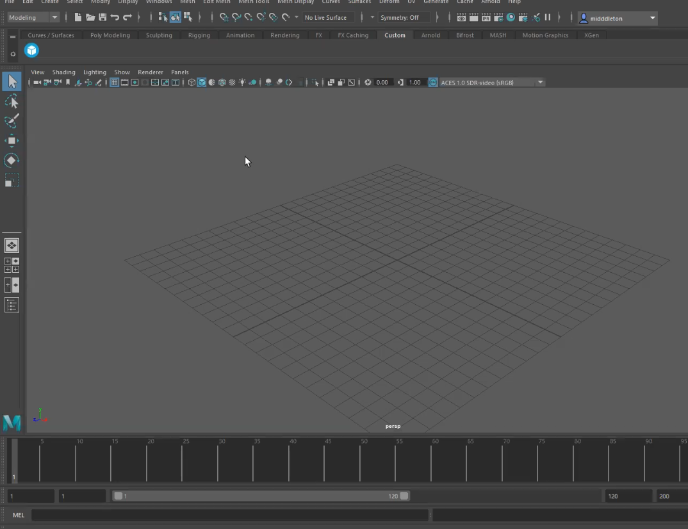

* Once your model populates, select any empty space in the window and press the spacebar to initiate a quad view (the spacebar toggles your view)

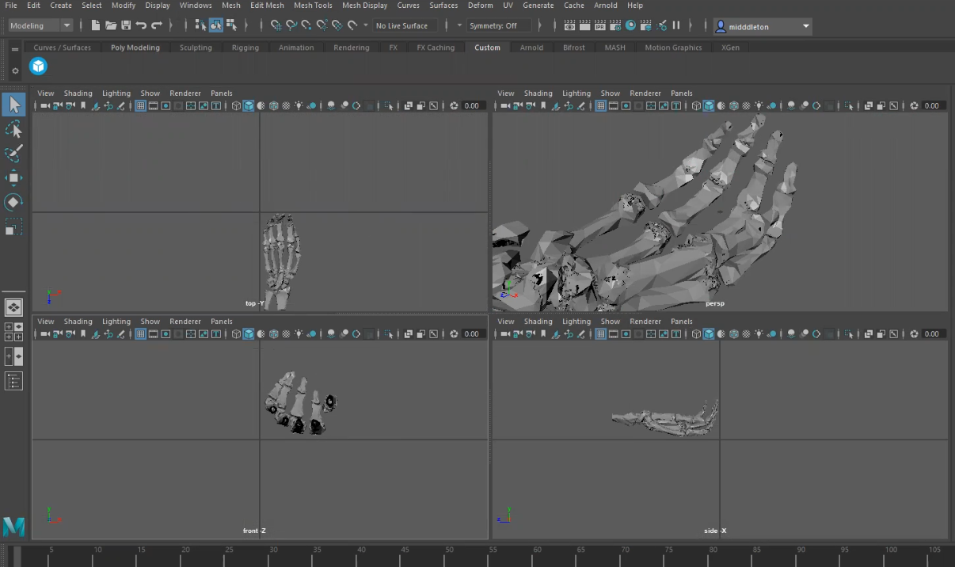

* Next you want to go up to Windows/General Editor/Hypergraph Hierarchy

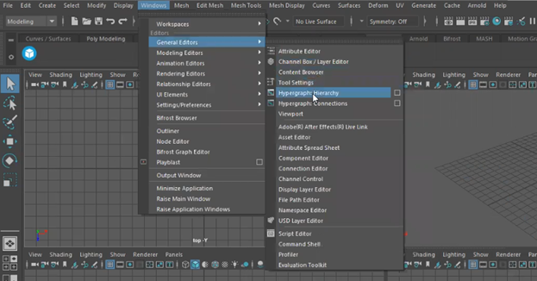

* Select everything in the scene

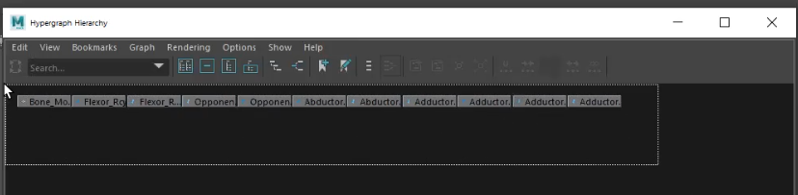

* Then go up to Edit/Group to combine everything (below shows before and after grouping)

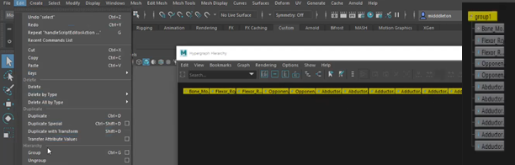

* Now click the translate icon on the far-left toolbar (square surrounded by four arrows) to populate the translation panel on the far right; this is where you'll enter your coordinates for the origin in the “Translate” boxes (in order x, y, z) under the “Transform Attributes” tab

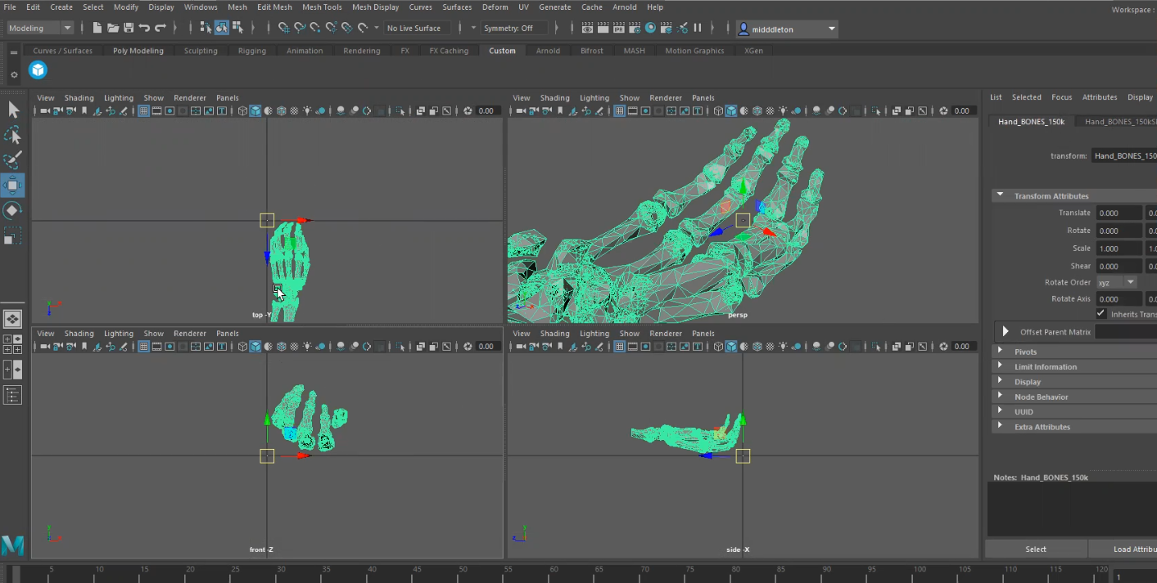

* Alternatively, if you don't know the coordinates of the origin you can eyeball your model into place by clicking and dragging it so that it appears to be aligned with the origin of the plane in all four windows

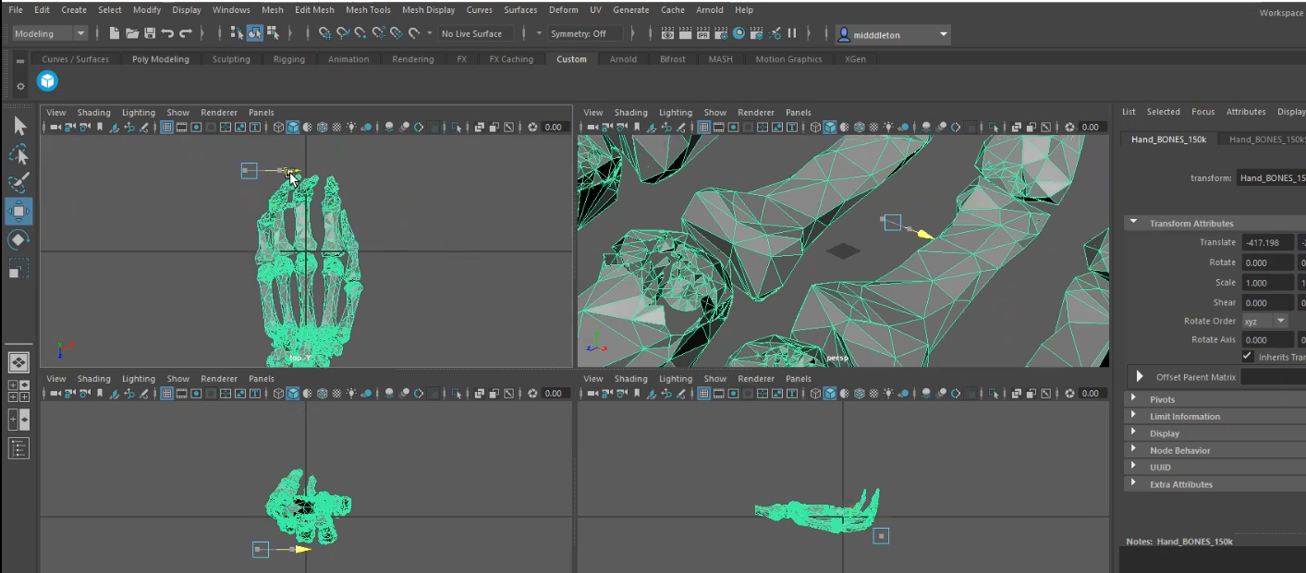

* You can also click the rotate icon (square surrounded by circle) in the far-left toolbar to then rotate your model so that it is better positioned about the origin

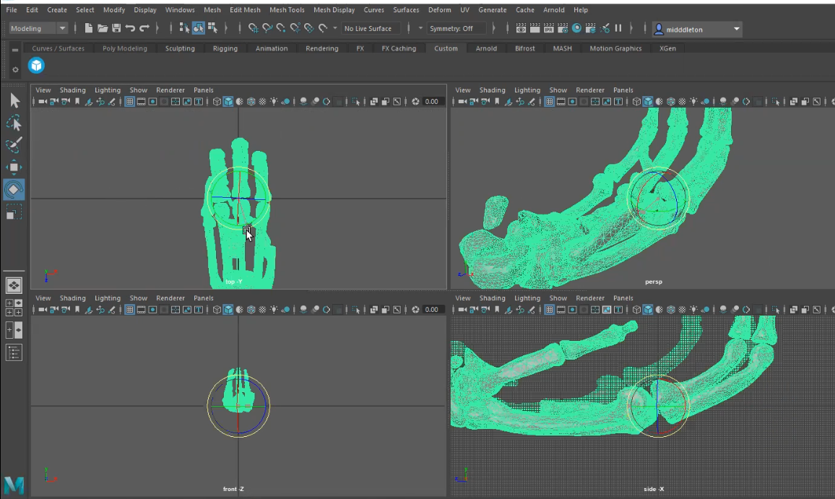

* Note that when you translate something, the rotational center does not move with it so you may have to go into the far-right panel, select the dropdown menu “Pivots” and under the “World Space” tab change the world rotate pivot values back to 0, 0, 0

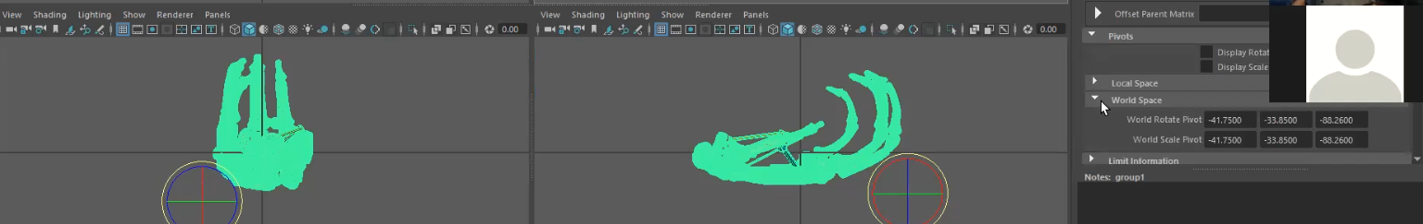

* Next you'll want to record both the translation and rotation xyz coordinates from the right-hand panel; these are the numbers that you will plug into Avizo to change the position of all your related models

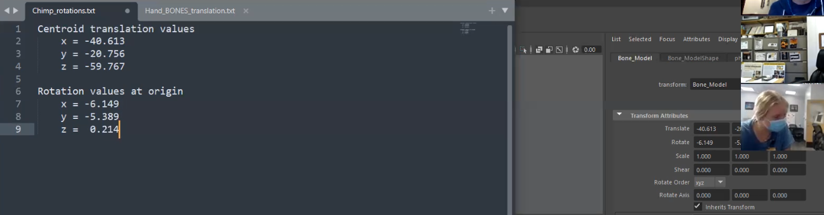

* Now back in Avizo, load your model and select the green data box - under Properties you'll then want to click the transform icon and scroll down until you find the Transform Editor

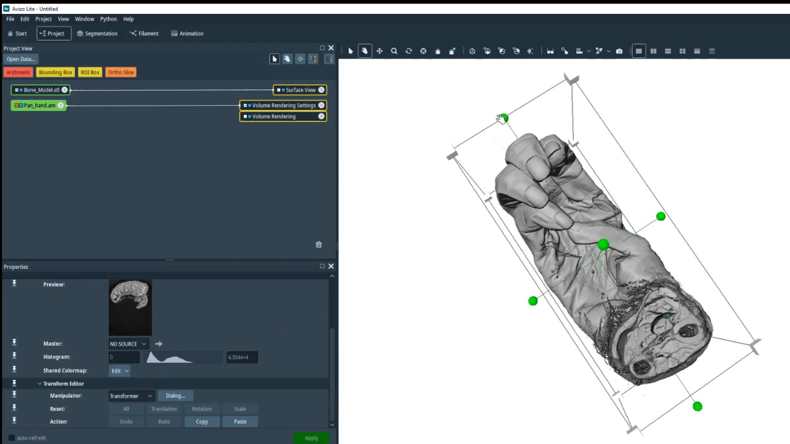

* Make sure the dropdown box is set to “Transformer” and then click the “Dialog…” box, this is where you’ll enter you coordinates from Maya; as you do so the model should start shifting in real time

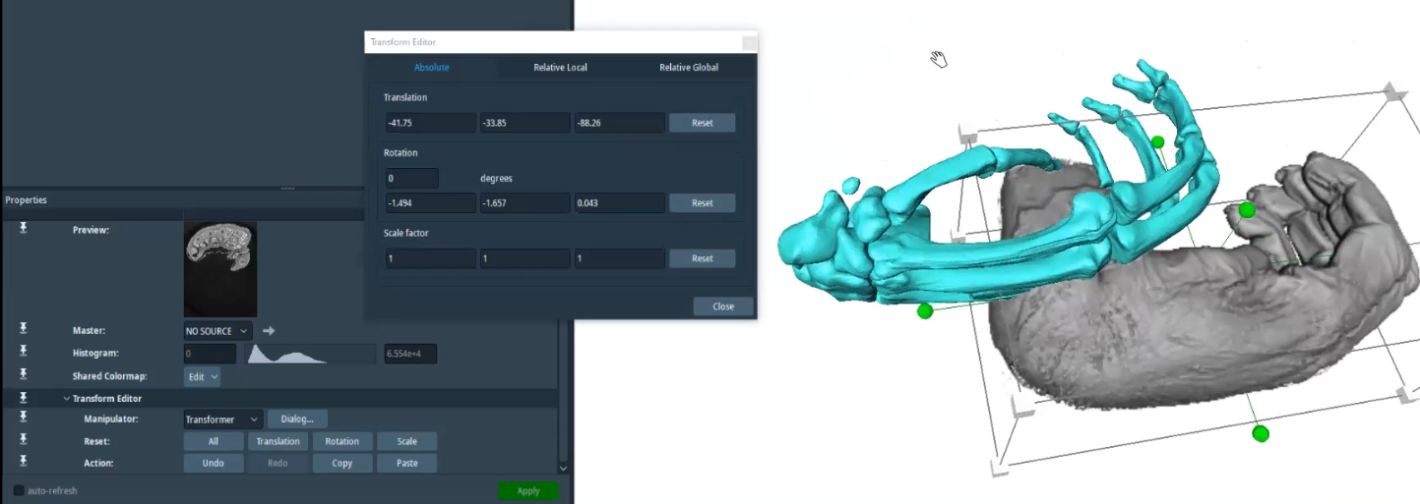

* When you're done you can close the transform editor and click apply if possible, although apparently clicking apply isn't a necessity and your changes should remain once you save your model
* Repeat these steps with all parts of your model that you wish to re-orient, when you're done make sure to save out all of your green data boxes by exporting them as little endian STL files or Avizo am files as appropriate

